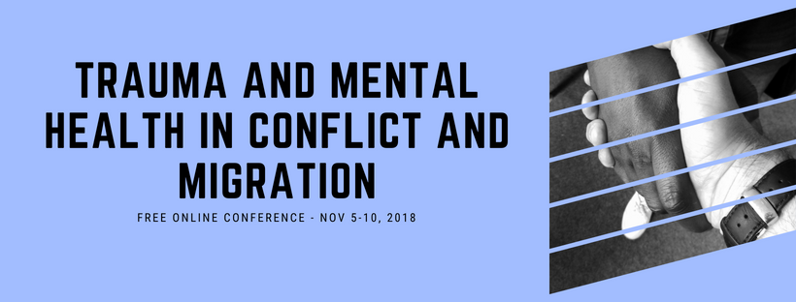

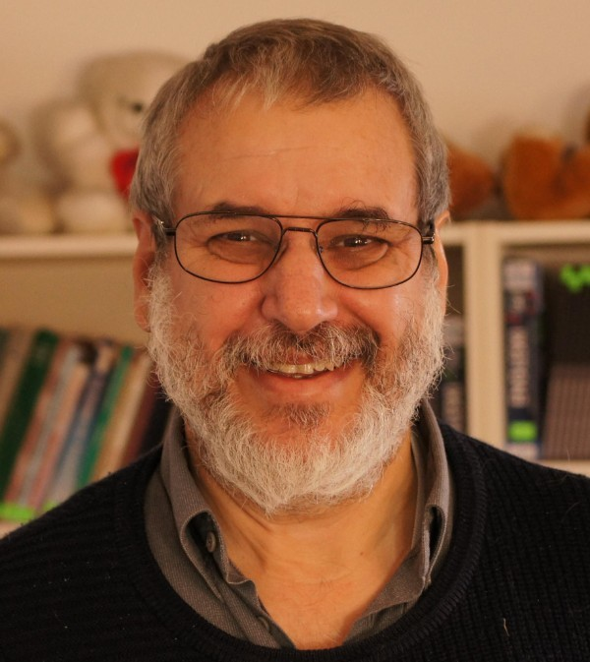

Charles David Tauber, M.D.
The current situation with regard to trauma in Croatia, Serbia, and Bosnia and Grassroots and Work with Psychological Trauma in Conflict and Post-Conflict Regions

Psychological work in the community with war victims, asylum seekers and refugees

Dr. Charles David Tauber will first describe the current situation with regard to trauma in Croatia, Serbia, and Bosnia, that is, with regard to civilian war victims, former soldiers, and the current generation, the last of whom are the victims of trans-generational transmission of trauma from the wars of the 1990s and previous conflicts.

Then, he will describe the situation with regard to asylum seekers and refugees in the Western Balkans and with regard to their integration in Western Europe. Further, he will describe the highly participatory methodology developed by the Coalition for Work with Psychotrauma and Peace, that is, Pragmatic Empowerment Training (PET), which works to train and supervise previously uneducated members of communities, this word in the broadest sense, to work with their peers, according to their own needs and desires. The CWWPP sees PET as a practical way of dealing with the lack of capacity with regard to traumatic reactions.

Charles David Tauber grew up in a family of immigrants in New York City. He has worked in movements for social change since 1966, starting with the environmental and peace movements. He studied chemistry and physics at Reed College in Portland, Oregon, where he also was active with the first actions of Greenpeace and with non-violent civil disobedience actions in the 1970s. He then studied medicine in Groningen, The Netherlands. After obtaining his medical qualification, he began to work with asylum seekers and refugees with the joint Amnesty International-International Physicians for the Prevention of Nuclear War Medical Examination Group and other local and regional groups in their support of asylum seekers and refugees’ efforts to obtain asylum. Also, he and other physicians were treating asylum seekers where other doctors weren’t willing to. They also were educating and psychologically supervising volunteers and staff members of other organizations working with asylum seekers.

When the wars in the former Yugoslavia broke out in the early 1990s, a number of the members of those groups formed a working group, from which the Coalition for Work with Psychotrauma and Peace, the CWWPP, was born. Tauber has worked in the former Yugoslavia as head of the CWWPP since June 1995. The aim of the CWWPP is to increase capacity at the grassroots level to work with psychological trauma and its physical consequences. The organization works with war victims and “people on the move”, otherwise known as migrants. The CWWPP uses a highly participatory method known as Pragmatic Empowerment Training, or PET, to assist people without previous education to assist one another. PET groups are given onsite and online without charge to the participants.

Copyright © 2018 Psychology for Peacebuilding, All rights reserved.

Our mailing address is: Psychology for Peacebuilding Prague
Praha 4, Czechia 14000

