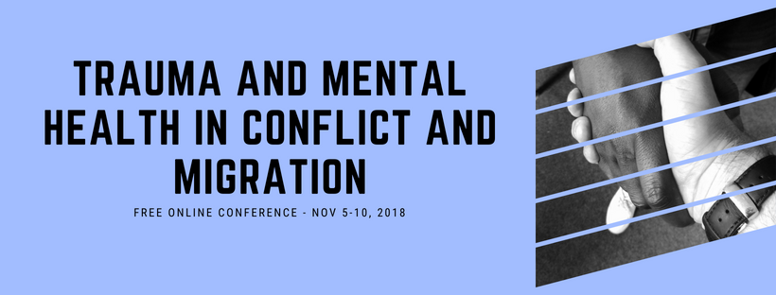

Angie Yoder-Maina and Belkyz Lopez

What is Trauma-Informed Conflict Transformation?

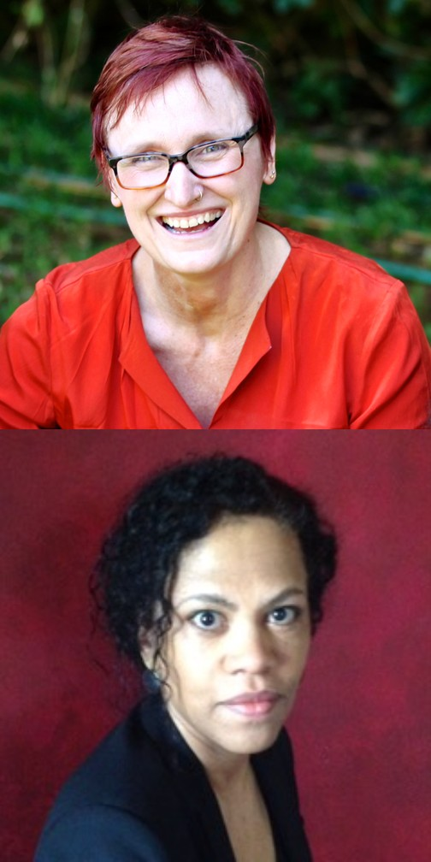
Trauma-Informed Conflict Transformation

Entire generations and nations are living in protracted violence and exist in survival mode for decades. The exposure to violence has
long-lasting effects that are not well accounted for in conflict analysis or stabilization efforts.
Extreme exposure to violent conflict negatively affects levels of resilience to violence and the ability of affected nations to transition from war to peace. Symptoms associated with trauma in individuals, influence all levels of society and aspects of governance and security, when large segments of a population are affected.
Grievances related to war, colonial pasts, economic inequality, tribalism, corruption, displacement, and sexual violence are especially difficult to address in regions suffering from extreme levels of mental distress. Trauma- informed approaches to conflict transformation consider mental distress to be a critical variable in violent conflict and instability.

Trauma-informed conflict transformation is a lens used to address protracted violence which impacts individuals, communities, systems, and structures. The approach is based on social cohesion building, social healing and finding trauma-informed solutions which communities in protracted conflict environments.

The focus is on the people which are ultimately charged with the difficult task of healing and transformation within their own context. It recognizes systems and structures should be supportive of recovery are often greatly damaged by conflict, and therefore often cannot provide the needed support to aid in the rebuilding process.

Trauma informed conflict transformation programming includes:

Understanding the physiological, emotional, cognitive, behavioral and spiritual impact of traumatic events (current or historic) on recipient populations, and how unaddressed trauma contributes to cycles of violence;

Going beyond traditional mental health diagnosis and symptoms of post-traumatic stress disorder as the measure of trauma impact, and also recognizing community and societal dynamics and behaviors are indicators of unaddressed trauma;

Identifying processes from multiple fields
—human security (including economic security), conflict transformation, restorative justice, neurobiology, psychology and spirituality—which can address the effects of trauma and increase resilience; and recognizing that addressing the psychological needs of populations creates the need to monitor staff for secondary trauma and to equip them with self-care skills and tools.

Angi Yoder-Maina is the CEO of a new local Kenyan NGO called Green String Network (GSN) based in Nairobi, Kenya. GSN brings together professionals and experts in the field of conflict transformation, governance, trauma-informed healing practices and development of sustainable economic programs.

The network encompasses likeminded actors who work on peace transformation, social healing and economic stability. GSN is keen on collaborations where local partners own and drive initiatives and benefit from our technical expertise. Our programs are creating opportunities for people currently in Somalia, Kenya, and Ethiopia at the most local level to learn about the effects of trauma, begin to heal and come together as a community to plan community-wide activities and structures to support further healing, and reconciliation.

In practice this involves developing context specific materials which are designed to teach community participants about the effects of trauma and provide a safe environment for them to share about how violence impacts their own lives. The context in the countries GSN is working in is one in which a cycle of violence has become the norm. This cycle sees people reduced to seeing themselves as victims, and unable to break free, or forced to become aggressors to survive. It is in such a context grassroots social reconciliation processes have the most to offer in breaking the cycles of violence and victimhood.

Entire generations and nations are living in protracted violence and exist in the survival mode for decades causing society’s social and economic fabric to disintegrate. Cracks in society are reflected in daily life, and not only affect individuals, but also the systems and structures that are meant to support recovery. A trauma- informed conflict transformation theory that comes from practice is necessary for addressing the ways trauma influences the different aspects of life and society – both at the individual and collective levels. Such an approach strengthens both individual and community resilience and supports the recovery process.

Angi is currently enrolled as a doctoral student at the Applied Conflict Transformation Studies Doctoral at the Centre for Peace and Conflict Studies in Siem Reap, Cambodia. Her dissertation is: “Trauma Informed Conflict Transformation Theory: A Grounded Study on Social Healing, Resilience and Recovery.”

Belkys López is a specialist in governance and peace-building, with a focus on post-conflict transitions in fragile states. Since the 2005 signing of the Comprehensive Peace Agreement in Sudan, she has worked in the critical border area of Abyei. She worked as a technical advisor for the government of South Sudan on the critical border issues and was there during occupation of the area by northern forces. She has worked extensively on conflict prevention and management, examining the impact of trauma and economic instability on peace. She has also worked on program design and management of development and emergency relief projects.

She currently works as a consultant and serves on the advisory board of KUSH Inc, a South Sudanese-American Non-Governmental Organization and DisasterAid an American emergency relief organization. Prior to her time in Sudan, she worked at the Annenberg Public Policy Center of the University of Pennsylvania and received fellowships for research carried out in South Africa and Cuba. Past research focus includes the role of non-state authorities in the global economy and the transforming nature of the state in regionalization. She earned a Master’s degree from the University of Warwick in International Political Economy and a BA in Political Science and Africana Studies from Bryn Mawr College.
Copyright © 2018 Psychology for Peacebuilding, All rights reserved.

Our mailing address is: Psychology for Peacebuilding Prague
Praha 4, Czechia 14000

