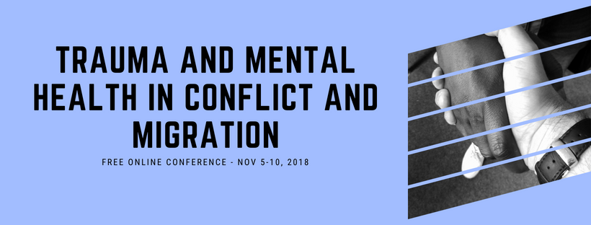
Stephen Sillett

Embodied processes helping groups to make sense of complex contexts and find change.

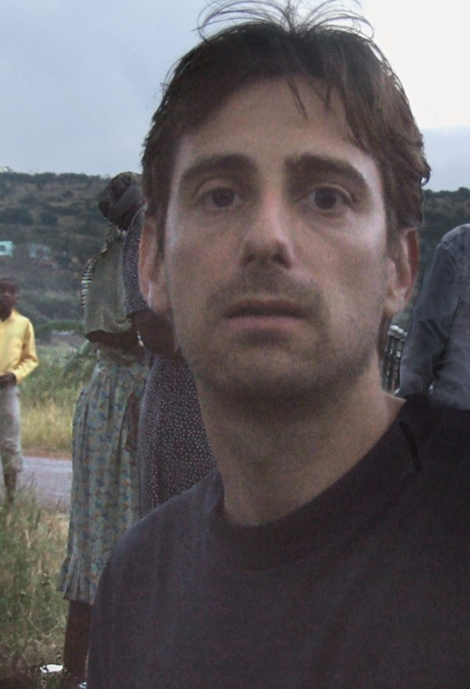

Healing, transporting, and transforming community in the midst of collective trauma

Stephen Sillett will talk about how working with a range of embodied processes, groups can make sense of complex contexts and start to find the resources to create personal and collective change. Speaking to the Socio-Drama Topography process developed in rural South Africa to support a participatory theatre play about peer influence. Stephen will describe how this spun off a range of innovative approaches to working deeply, and safely with communities experiencing the trauma of HIV/AIDS. These approaches could have new applications in trauma and healing work, and Stephen invites people to see how such approaches could be used in their work.

Stephen Sillett is co-executive director and co-founder of Aiding Dramatic Change ~ in Development (ADCID).
Stephen helps the organization research, facilitate and design: dialogue, drama and art processes for healing and community development. Through ADCID projects and in partnership with other social actors, he is exploring approaches that engage community members in conversations, consciously orientated to maturing visions of the future.

As part of configuring complex projects, Stephen is developing applications of his InFusion Trans-disciplinary Framework, which helps ethically configure different fields of strategic action, including psycho-social support. As part of this development he directs InFusion Labs where theatre artists, therapists, scientists and social practitioners explore spatial approaches to sense- making. Recently Stephen worked with McMaster University Department of Social Sciences on a two-year study Mapping the Self in Public Space: People with Intellectual Disabilities Everyday Use of City Space.

Copyright © 2018 Psychology for Peacebuilding, All rights reserved.

Our mailing address is: Psychology for Peacebuilding Prague
Praha 4, Czechia 14000

